

**the republic of uganda**

**GUIDELINES FOR TRANSITIONING TO PROGRAMME PLANNING AND BUDGETING APPROACH**

1. **INTRODUCTION**
2. The Third National Development Plan (NDPIII) whose goal is to increase household income and improve the quality of life of Ugandans has adopted a programme approach to planning, budgeting, implementation and reporting. This approach takes into account the programme based budgeting approach and performance-based budgeting to address the persistent implementation challenges resulting from uncoordinated planning, weak harmonization, limited sequencing of programmes and poor linkages between outcomes and outputs. 18 national Programmes have therefore been identified with well-articulated results, objectives and interventions to achieve this goal.
3. **WHY THE PROGRAMME APPROACH**
4. The programme approach is meant to enable formulation of national priority development objectives and to realize these objectives through corresponding national programmes formulated and implemented in a coherent, coordinated and participatory manner to ensure sustainability. The programme approach to planning aims to:
5. Focus implementation of the NDPIII programmes on delivery of common results;
6. Strengthen alignment of planning and budgeting frameworks to provide a logical framework for anchoring the Program-Based Budgeting System (PBS);
7. Enhance synergies across sectors and other actors to reduce a ‘silo’ approach to implementation; and,
8. Provide a coordinated framework for implementation, monitoring and reporting for improving delivery of results.
9. Implemetation of the Programme Approach will therefore address the criticism that Government MALGs work in ‘silos’ as it provides a framework for inter and intra-sectoral coordination.
10. The purpose of these guidelines, therefore, is to support the transition to this programme approach. The guidelines aim at ensuring the promotion of ownership, harmonization, alignment, management of results, and mutual accountability across all implementers of the NDPIII. Specifically, these guidelines aim to achieve the following:
11. Increase appreciation of the programme planning approach among the various NDPIII stakeholders;
12. Highlight the implications of programme approach to the planning, budgeting, implementation and reporting frameworks; and,
13. Define the mechanisms for programme leadership and secretariats.
14. **THE NDPIII PROGRAMME ARTICULATION**
15. The NDPIII has been conceived along 18 programmes as listed in table 1 below.

**Table 1: The NDPIII Programme Articulation**

| **NDP III Objectives** | **NDP III Strategies** | **NDP III Programs** |
| --- | --- | --- |
| Enhance value addition in Key Growth Opportunities | 1. Promote agro-industrialization 2. Increase local manufacturing activity 3. Promote mineral-based industrialization 4. Harness the tourism potential 5. Promote export-oriented growth | 1. Agro-Industrialization 2. Mineral Development 3. Petroleum Development 4. Tourism Development 5. Water, Climate Change and ENR Management |
| Strengthen private sector capacity to drive growth and create jobs | 1. Provide a suitable fiscal, monetary and regulatory environment for the private sector to invest 2. Increase local content participation | 1. Private Sector Development 2. Manufacturing 3. Digital Transformation |
| Consolidate & increase stock and quality of Productive Infrastructure | 1. Institutionalise infrastructure maintenance 2. Develop intermodal transport infrastructure 3. Increase access to reliable & affordable energy 4. Leverage urbanization for socio-economic transformation | 1. Transport Interconnectivity 2. Sustainable Energy Development 3. Sustainable Urban Development |
| Increase productivity, inclusiveness and wellbeing of Pop’n | 1. Improve access and quality of social services 2. Institutionalise HR planning 3. Enhance skills and vocational Development 4. Increase access to social protection Promote STEI 5. Promote development-oriented mind-set | 1. Human Capital Development 2. Community Mobilization and Mindset Change 3. Innovation, Technology Development & Transfer 4. Regional Development |
| Strengthen the role of the State in development | 1. Increase govt. participation in strategic sectors 2. Enhance partnerships with non-state actors for effective service delivery 3. Re-engineer Public service to promote invests. 4. Increase Resource Mobilization | 1. Governance and Security Strengthening 2. Public Sector Transformation 3. Development Plan Implementation |

1. **OPERATIONAL PROGRAMMING DEFINITIONS**
2. The following definitions apply:
3. **The Third National Development Plan (NDPIII)**

The NDPIII will provide the overarching national strategy from which all strategic plans at the Ministry and Local Government levels will be drawn.

1. **Programme**

A programme refers to a group of related interventions that are intended to achieve common outcomes within a specified timeframe. Programmes were identified on the basis of key development issues that need to be addressed to achieve the overall goal, objectives of NDP III along with corresponding strategies of NDP III and aspirations towards achievement of Uganda Vision 2040. The summary of programme logic is as follows:

**Figure 1: Summary of NDPIII program logic**

**Programme X**

**Development issue being addressed**

**Programme Goal**

**Programme Objectives**

**Programme Outcomes**

**Interventions**

**Outputs**

**Sub-Programmes**

1. **Programme Implementation Action Plan (PIAP)**

A PIAP provides details of the activities and resources required to deliver the programme targets. Draft PIAPs have been developed. The PWGs are required to finalise the PIAP, working with NPA.

1. **MDA Strategic Plan**

The MDA plan translates the NDPIII goal, objectives and programmes to MDA level goals, objectives and outputs, through their MDA Strategic Plan. It will be linked to the PIAP and will be the basis for preparing an annual budget.

The Strategic Plan must contain information on the vision, mission, goals and objectives of the Ministry as well as linkages to Programme Outcomes, outputs and the inputs required to achieve them. Performance information in the Strategic Plans should be linked directly to performance information in the PBB so as to provide a mechanism for reporting measurable progress at the end of the year.

1. **Programme Political Leader**

This is the political head of the Ministry designated to coordinate implementation of a programme, who is the Hon. Minister. The Programme Political Leader will provide leadership in implementing the programme that brings together several state and non-state actors. The Terms of Reference for the Programnme Political Leader are defined in **Section xxx** of these guidelines.

1. **Programme Technical Leader**

This is the Permanent Secretary of the Ministry designated to coordinate implementation of a programme. The Programme Technical Leader will provide will provide technical leadership in implementing the programme that brings together several state and non-state actors. The The Terms of Reference for the Programnme Technical Leader are defined in **Section xxx** of these guidelines.

1. **Programme Clusters**

This is a cluster of Programmes that contribute to one single objective of the NDPIII.

1. **Programme Cluster Coordinators**

These are the five (5) Commissioners in charge of coordination of the Programme Clusters under the Directorate of Coordination at the Office of the Prime Minister. The The Terms of Reference for the Programnme Cluster Coordinators are defined in the *Monitoring and Evaluation Framework of the NDPIII*, attached as **Annex xxx**.

1. **Programme Working Group (PWG)**

PWGs are technical working fora, within the overall NDP programme approach, in which Government (*all MDAs under the Programme*) and other stakeholders are supposed to discuss and agree on:

1. Inter and intra agency planning;
2. Priority interventions and Resource allocation;
3. Delivery of services; and,
4. Joint monitoring & evaluation of multi-agency activities.

The Terms of Reference for the Programnme Working Groups are defined in Section xxx of these guidelines.

1. **Programme Review**

An annual process involving reporting on the progress made towards implementation of the NDPIII programmes at national, MDA and LG levels.

1. **Vote**

This is an MDA/Local Government

1. **Sub-Programmes/ Directorates**

These are administrative units within the institutions that implement Government Programmes and Projects.

1. **Departments**

These are administrative units within the institutions that implement activities.

1. **Project**

A project is a series of tasks that need to be completed in order to reach a specific outcome. These represent a set of activities that primarily involve capital purchases and can be financed by the Government of Uganda and/or Development Partners. Under the Programme Planning Approach, projects will report to relevant departments. It should be noted that some projects cut across Programmes as they contribute to more than one Programme, hence ... (Ag. DDCP to provide statement)

1. **IMPLICATIONS TO PLANNING, BUDGETING, IMPLEMENTATION, MONITORING AND EVALUATION AND REPORTING**
2. **Implications to Planning Frameworks**
3. **A shift from Sectoral Planning and Coordination to Programme Planning and Coordination**
4. Since the NDPIII is based on the programme approach, the Sector Working Groups (SWGs) will now be replaced by the Programme Working Groups (PWGs). Coordination will thus be along the NDPIII Programmes as opposed to the previous Sector Wide Approaches. The Office of the Prime Minister (OPM) will be responsible for the overall coordination of implementation of the NDPIII programmes. MALGs are expected to coordinate and harmonise their plans through the Programme Working Groups, and to avoid working in silos.
5. The NDPIII will remain the overall strategic document guiding the country towards achievement of the Uganda Vision 2040. Programme Implementation Plans (PIAPs) will be introduced and will constitute a link between the MDA/LG Plans to the NDPIII. PIAPs will be results and action based with annualised targets and costs for the five-year period. They will be the basis for development of MDA strategic plans and LG plans. Key elements of the PIAPs are shown in Figure 3 (the draft PIAPs are attached as **Annex 1**).

***Figure 3: Elements of the NDPIII PIAP Results Chain***

Objective level Outcome indicators

Programme level Outcome indicators

Output indicators and targets

*Programme Outcomes*: Changes brought about by public interventions upon individuals, social structures, or physical environment

*Outputs:* A good or service provided by an MDA. Eg patients’ treatments, Functional Intensive Care Units (ICUs), irrigation dams.

*Actions:* types or categories of work process undertaken in the production and delivery of outputs. Eg nursing, Establishing ICUs, constructing irrigation dames

*Annualized Costs*: Financing requirements to deliver actions per year

**Decentralized Planning level**

1. **Preparation of Strategic Plans for Ministries, Agencies and Local Governments (MALGs)**
2. MALGs shall prepare strategic plans that are in line with their respective NDPIII PIAPs. The MALGs plan should set out the direction the Ministry intends to take in order to reach its intended goal and should specify the Directorate and Department linked to the relevant NDPIII programmes with operational objectives. It will also identify corresponding interventions, outputs and activities adopted from the NDPIII or adapted (customized to NDPIII) required to achieve this. Figure 4 shows the link between the NDPIII PIAP and the MDA strategic plan.
3. The MALGs will be the budgeting centers under Programme Based Budgeting, as indicated in **Figure 7** below. The link between the NDPIII Programmes, Objectives and Interventions to the PIAPs and MDA Plans in illustrated below:

**Table 2: Linking NDPIII Programmes, Objectives and Interventions to PIAPs & MDA Plans**

| **NDPIII Goal:** | **MDA Goal:** |
| --- | --- |
| **NDPIII Objectives:** | **MDA Objectives:** |
| **NDPIII programme outcomes** | **Adopted NDPIII programme outcomes/specific MDA outcomes** |
| **NDPIII Programs that an MDA will contribute to** | **MDA Directorates**  **MDA Departments** |

**Figure 4:** **Link between the PIAP, MDA and LG Level Plans**

**MDA Strategic Plan**

1. In order to demonstrate the Structure of the Programme Approach, two examples have been provided below, for one institution under Agro-Industrialisation and for one institution under Human Capital Development (planning framework).

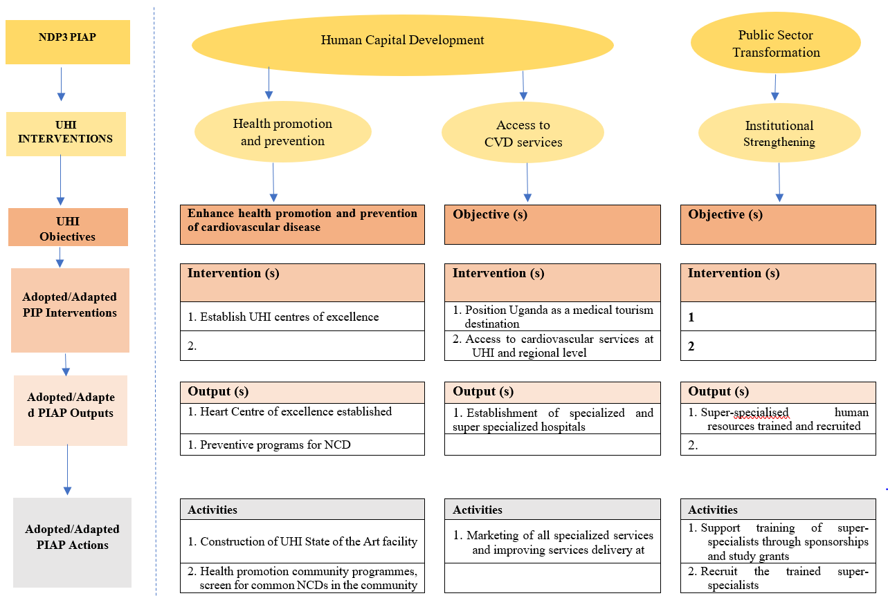

**Figure 5: Illustration Using Uganda Heart Institute (UHI) Strategic Plan**

# C:\Users\cmatovu\Downloads\MTIC.PNG

**Figure 6: Illustration of Ministry of Trade, Industry and Cooperatives Strategic Plan Framework**

1. **Implications to Programme Based Budgeting**
2. Government adopted the Program Based Budgeting in FY2017/18 in order to match the Budget with outputs, outcomes, measurable objectives and performance measures. Implementation of the NDPIII will call for a restructuring of the PBB to mirror the 18 programmes and outcomes.
3. The PIAPs together with MDA strategic plans will form a foundation on which the PBB will be formulated. The MDA strategic plan and its budget framework papers will should be aligned in terms of sub-programmes, outcomes and sub-outputs. Figure 7 shows the proposed structure of the Programme Based Budget and alignment to the NDPIII.

**Figure 7: Proposed PBB-PBS Structure – Alignment to the NDPIII**



1. In order to demonstrate the Structure of the Programme Approach, two examples have been provided below, for one institution under Agro-Industrialisation and for one institution under Human Capital Development (budgeting structure).
2. **Implications to Programme Implementation Coordination Led by Office of the Prime Minister**

**Programme Leadership and Coordination at Office of the Prime Minister**

1. As the leader of Government Business and the overall coordinator, the Prime Minister will be responsible for overall leadership of NDPIII implementation. OPM will therefore house a secretariat that will consolidate progress report from Ministries leading the implementation of individual programmes. Through the APEX platform (see figure below), the OPM will submit an Annual Government NDPIII Programme Performance Report to H.E. the President.

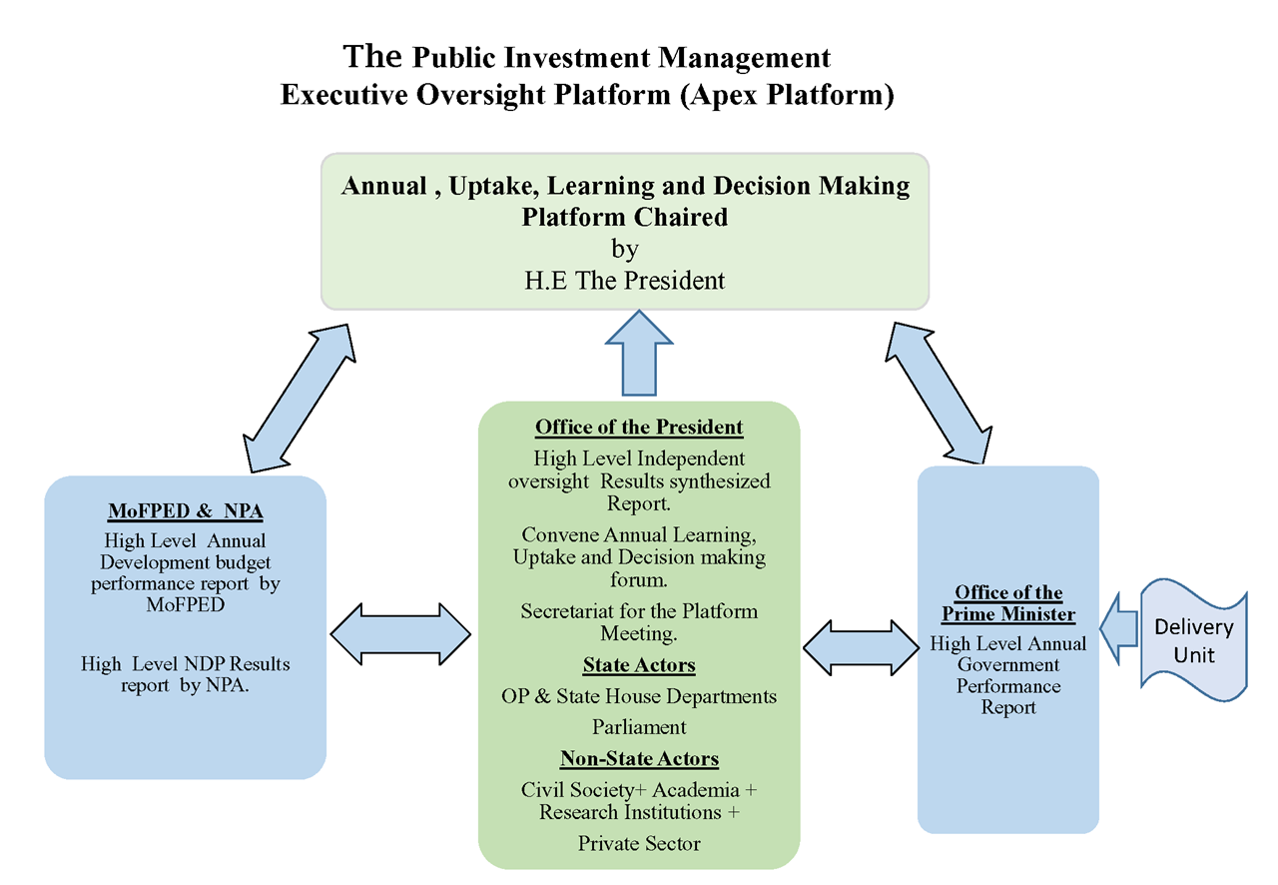

***Note:*** *In the above Apex platform, Office of the President will be responsible for results analysis whereas the Office of the Prime Minister will be responsible for Programme Implementation Coordination.*

1. Specifically,
2. The Rt. Hon. Prime Minister/ Leader of Government Business will provide the overall political leadership for programme implementation.
3. The Permanent Secretary/ Office of the Prime Minister will be the technical head of the secretariat and will report to the Prime Minister. The Terms of Reference for the Office of the Prime Minister are highlighted in **Section xxx** below.

**Programme Leadership and Coordination at Institutional Level**

1. For each programme, the lead Minister will be the political programme coordinator. In the event of absence of the lead minister, a senior minister from one of the agencies under the programme leads the process. **Table 3** shows proposals for leadership by programme, whereas **Annex 2** provides details of the institutions under the different Programme.
2. The criteria that was used as the basis for selection of Programme Leadership was the number interventions by the institution in the Programme.

**Table 3: The NDPIII Programme Leaders**

| **S/N** | **Programme** | **Chair** |
| --- | --- | --- |
|  | Agro-Industrialization | MAAIF |
|  | Mineral Development | MEMD |
|  | Private Sector Development | MoFPED |
|  | Digital Transformation | MoICT&NG |
|  | Human Capital Development | MoES |
|  | Sustainable Development of Petroleum | MEMD |
|  | Manufacturing | MoTIC |
|  | Tourism Development | MoTWA |
|  | Natural Resources, Environment, Climate Change, Land and Water Management | MoWE |
|  | Sustainable Energy Development | MEMD |
|  | Integrated Transport and Services | MoWT |
|  | Sustainable Urban Development | MoLHUD |
|  | Technology Transfer and Development | MoSTI |
|  | Regional Balanced Development | MoLG |
|  | Community Mobilization & Mindset Change | MoGLSD |
|  | Public Service Transformation | MoPS |
|  | Governance and Security | OP |
|  | Development Plan Implementation | MoFPED |

1. The selection of an institution to lead a programme is based on the fact that majority of the programme interventions fall under that institution. The Terms of Reference for the Programme Lead Ministers are indicated in **Section xxx** below.

**Programme Secretariat**

1. The secretariat will be housed at the Ministry leading the programme. The Permanent Secretary of the lead institution in a Programme will be the technical head of the Programme Working Group, supported by the Planning Department/Unit. This level will undertake day to day running of the Programme and produce periodic programme performance reports. The Terms of Reference for the Programme Technical Heads are indicated in **Section xxx** below.

**Table 4: Ministry and OPM Level Secretariats**

| **Cluster** | **Lead MDA Secretariat** | **Cluster Secretariat under OPM** |
| --- | --- | --- |
| Cluster I: Value Addition Cluster | Agro-Industrialization | Cluster I: OPM Minister 1 |
| Mineral-based Industrialization |
| Petroleum Development Program |
| Tourism Development Program |
| Natural Resources, Environment, Climate Change, Land and Water Management |
| Cluster II: Private Sector Strengthening Cluster | Manufacturing | Cluster II: OPM Minister 2 |
| Private Sector Development |
|  |
|  |
|  |
| Cluster III: Infrastructure Development Cluster | Digital Transformation | Cluster III: OPM Minister 3 |
| Sustainable Energy Development |
| Technology Transfer and Development |
| Intergrated Transport Infrastructure and Services |
|  |
| Cluster IV: Well-being and Productivity Cluster | Human Capital Development and Social Protection | Cluster IV: OPM Minister 4 |
| Community Mobilization and Mindset Change |
| Regional Development Programme |
| Sustainable Urban Development |
|  |
|  |
|  |
| Cluster V: Public Sector Strengthening Cluster | Public Sector Transformation | Cluster V: OPM Minister 5 |
| Development Plan Implementation |
| Governance and Security |
|  |
|  |
|  |

**Programme Working Groups**

1. Programme Working Groups (PWG) will replace Sector Working Groups(SWGs) and will be led by the Minister of the lead Agency. The PWG will be composed of the following representatives of participating agencies: Permanent Secretaries – Chairpersons/PWGs, Heads Planning/Line Ministries – Secretaries/PWGs, Accounting Officers under the programme – Members/PWGs, Desk Officers/MoFPED represent MoFPED in the Programme Meetings, Heads of departments/NPA, Development Partners and other Non-State Actors. The PWGs will be reguired to meet regularly, but in any case, not less than once a quarter. The Terms of Reference for the PWGs are indicated in **Section xxx** below whereas the details of the different MDAs in the different PWGs are indicated in **Annex xxx** attached.
2. **Implication to Data Production and Management**
3. The data production frequencies will have to be synchronised with the NDPIII data needs. In particular, given the fact that the programme-based planning focuses on outcomes, there will be need for integrating various surveys and/or conducting surveys that cover outcome indicators of the NDP. Therefore, designated data collection cycles will have to be observed. All surveys will need to be conducted simultaneously in selected “survey periods’’. This will require capacity to collect data as well as establishing a survey fund which will be a one-off every five years.
4. **Implication to Project Approval Processes**
5. Under the existing arrangements, projects are approved by Project Preparation Committees (PPCs) of individual MDAs. This approval process will have to shift so that projects are approved by the Programme Working Group constituted by all agencies under a given programme.
6. **Implication to Development Partner Coordination**
7. Support from Development Partners will have to be channeled through along the NDPIII Programmes. The UN Sustainable Development Assistance Framework will have to be aligned to the NDPIII programme approach to ensure coherence in development support geared towards delivering the NDPIII programme results.
8. **Policy Implications of aligning the Budget to Programs**
9. Projects not in the right programs should be aligned to the correct programs e.g PRDP and NUSAF
10. Sector Working Group Secretariats that are currently functional should be transformed to Program Working Group Secretariats.
11. **Implications for Monitoring and Evaluation**

*Office of the Prime Minister to provide the required text.*

**Implications to Reporting Frameworks**

1. At the national level, an integrated web-based M&E system will be developed to for tracking progress of NDP implementation. The apex platform, an executive forum that brings together the Office of the President, OPM, MoFPED and NPA shall be strengthened to reflect on outcomes derived from implementation of NDPIII programmes and escalate issues that require the action of the cabinet and presidency.
2. **Implications for Restructuring of Government**

The Programme Approach will necessitate the restructuring of Government so as to eliminate the duplication of roles, and to enhance efficiency and effectiveness during implementation.

1. **TERMS OF REFERENCE (TORS) FOR PROGRAMME COORDINATION AND IMPLEMENTATION**
2. The following will be the terms of reference for Programme Coordination and Implementation.
3. **ToRs for the Office of the Prime Minister**
4. As the leader of Government Business and the overall coordinator for implementation of Government Policies across Ministries, Departments and other Public Institutions, OPMs leadership is critical in coordinating the implementation of the 18 NDPIII programmes.
5. The roles and responsibilities of OPM are outline below:
6. The Rt. Honorable Prime Minister will be the overall political programme implementation coordinator. He will be responsible for the following:

* Steer policy and strategic engagements with all Ministers in charge of implementing particular programmes interventions for the NDPIII results;
* Hold Ministers accountable to deliver results; and,
* Report to the President on progress of Programme Implementation.

1. The Permanent Secretary will be the technical head of the secretariat and will report to the Prime Minister. He will be responsible for the following:

* Steer strategic and technical engagements with all Ministers in charge of implementing particular programmes interventions for the NDPIII results;
* Report to the Prime Minister on progress of Programme Implementation.

1. **ToRs for the Programme Lead Ministers**
2. The lead Minister as identified above will provide policy guidance and hold the technical leadership accountable for implementation of the programme.
3. **ToRs for the Programme Technical Leaders**
4. The programme Technical Leaders will be responsible for coordinating the implementation of Programme interventions at the following levels: (i) Planning; (ii) Budgeting; and, (iii) Reporting.
5. **Program Planning**
6. The lead Ministry will be responsible for implementation of the Programme. Through the Program Working Group (PWG) coordinated by a technical secretariat under the technical guidance of the Planning Unit, all stakeholders will be convened to set the priorities for implementation, identify the key policy and project requirements, identify key implementation bottlenecks to be resolved, among others. The priorities for the subsequent financial year will be set during the second quarter (August – October) of the running financial year. The priorities identified must be in line aligned to the NDPIII. The timelines for implementation of the alignment of the Budget to the NDPIII Programme Approach are as indicated in **Annex xxx**.

1. The agreed outputs and priorities will translate into annual programme action plans for each implementing entity. The action plans will be submitted annually to the Office of the Prime Minister for approval.
2. **Budgeting**
3. The lead minister will coordinate the development an annual Programme Budget Framework Paper (PBFP). This will be done in consultation with all relevant stakeholders of the programme and shall be a consolidation of each vote BFP.
4. The Overall program coordinator at OPM in liaison with NPA, should ensure that the final budget estimates are intended to finance the agreed priorities and actions of the program generated by the Program Working Group (PWG).
5. **Monitoring and Reporting**
6. The lead Ministry will prepare quarterly and annual programme reports on the progress of the results of the programme and submit to the programme coordinator at OPM.
7. **ToRs for the Programme Working Groups (PWGs)**
8. PWGs are responsible for preparation of Programme Implementation Plans, preparation of Programme Budget Framework Papers (PBFPs) and the medium-term budget strategy documents. Specifically;
9. Ensure broad stakeholder consultation in discussing key issues and harmonize Government and stakeholder positions;
10. Formulate Programme Implementation Plans in line with the National Development Plan and the Manifesto of the ruling government;
11. Joint clearance of projects for inclusion in the Public Investment Plan, a requirement by the Development Committee;
12. Ensure Implementation of Program Based Budgeting (PBB) for proper alignment to the NDPIII;
13. Coordinating inter-ministerial and agency budget allocations in a consultative way ensuring transparency and accountability.
14. Ensuring that consultations are carried out between line ministries, and external and internal stakeholders on matters related to the programme;
15. Examine and review of programme related policies and plans, reviewing past performance, emerging policy issues and future spending pressures;
16. Identifying key outputs and programme performance targets both annually and in the medium term;
17. Undertaking monitoring and assessment of programme interventions; and,
18. Preparing semi-annual and annual programme reviews and reports.